Grant Kim

Instructor Zack Goodman

Poli 5D

7 June 2019

Financial Globalization and GDP PPP per Capita

**1. Motivation & Research Question**

In the International Political Economy discipline, scholars argue about the economic and political consequences of globalization. Some scholars argue that there are winners and losers in globalization. Others claim that globalization promotes economic growth for developing countries, allowing convergence of these countries to developed countries (Oatley). However, there is less debate on whether globalization leads to increased standard of living. Assessing the impact of globalization on standard of living may be as equally as important as measuring economic growth at a country level for modern audiences because standard of living applies to every individual in that country. Therefore, this project will attempt to will attempt to analyze the impact of economic globalization on a micro-level.

**2. Theory, Operationalization, Datasets, Hypothesis, Causal Mechanism**

**2.1 Theory and Variable Lists**

Our theory is that the economic globalization of a country will increase the standard of living for that country. In order to generate a hypothesis that assesses this theory, the concept of economic globalization and standard of living must be operationalized. To measure economic globalization as our X1 variable, we will use the “lagged financial globalization indicator (de jure)” from the KOF Swiss Economic Institute Globalization Index Dataset. To measure standard of living as our Y variable, we will use the GDP Purchasing Power Parity per Capita adjusted for inflation (2011 international $) from the World Bank database “databank.” Also, there are two control variables. The first control variable, X2 is the “trade globalization indicator (de jure)” from the KOF Swiss Economic Institute Globalization Index Dataset. Second control variable X3 is the “total labor force as a percentage of population 15-64” from the CDPS dataset.

**2.2 Reason for choosing certain variables**

The “financial globalization indicator (de jure)” was chosen as the main independent variable X1 for two reasons. First, we must observe what the KOF Globalization Index is composed of. As shown in appendix 1, the KOF Globalization Index is composed of 12 different indicators, which are categorized into 3 different types of globalization: Economic, Social, Political Globalization. Since we are operationalizing the concept of “economic globalization” as a measurable independent variable, we can confidently exclude Social and Political Globalization indicators since they measure social and political globalization. In turn, we are left with the Economic Globalization category.

The Economic Globalization category is composed of 4 different indicators: Trade Globalization (de facto), Trade Globalization (de jure), Financial Globalization (de facto), and Financial Globalization (de jure). We exclude “de facto” version of the indicators because they are mechanically related with GDP. For example, the Financial Globalization (de facto) measures Foreign Direct Investment as a percentage of GDP, which is part of GDP PPP Per Capita. Then, we are left with Trade Globalization (de jure) and Financial Globalization (de jure). Both indicators are sufficient to be our dependent variable. Comparing the measures that are used within the indicators, financial globalization (de jure) arguably provides a more holistic view of economic globalization. Financial globalization (de jure) measures capital account liberalization which ultimately leads to financial integration of a country with the global economy. On the other hand, trade globalization (de jure) is only limited to trade openness of a country which does not necessarily indicate integration of a country with the global economy. Therefore, financial globalization (de jure) will be used as our X1. However, it must be recognized that this argument is tentative and “trade globalization (de jure)” can be used as X1 for further research. Additionally, our X1 is lagged by 1 because the we think that the financial globalization of a country in the previous year leads to increased GDP PPP Per Capita in the current year.

In order to accurately analyze the association between X1 and Y, other variables that might affect Y should be included in our control variable. In turn, “Trade Globalization (de jure)” indicator will be used as a control variable X2 because it is also a part of economic globalization that can effect GDP PPP Per Capita. Additionally, “total labor force as a percentage of population 15-64” will also be our control variable X3 because countries with higher labor force participation rate are more likely to have higher productivity, which leads to a higher GDP PPP Per Capita.

Lastly, the GDP PPP Per Capita (Constant 2011 international $) is chosen as the dependent variable. Since the “constant” adjusts for inflation and the Purchasing Power Parity allows any monetary income to be compared in relation to the amount of goods and services it can buy locally, GDP PPP Per Capita can capture the monetary aspect of the standard of living. From these operationalized variables the following hypothesis is generated: “Over a specified period of time, if the financial globalization (de jure) indicator of a country increases, the GDP PPP Per capita of that country should increase.”

**2.3 Casual Mechanism**

The Financial globalization (de jure) indicator measures investment restrictions, capital account openness and international investment agreements. In turn, increased financial globalization (de jure) indicator should increase a country’s access to productivity enhancing foreign capital. This increase in capital should lead to an increase in productivity of that country. Increased productivity should increase the likelihood of growth in income for an individual or a firm which should ultimately lead to increased GDP PPP Per Capita of a country. For the increase in productivity of a corporation, the assumption is that wealth trickles down to individuals in generally albeit it is not always true.

**3. Statistical Analysis**

**3.1 Dataset Merged and Unit of Analysis (Refer to R script Section 1)**

As a result of merging 3 different datasets, missing values for some periods were created. As a result, we confine our analysis to the time period from 1990 to 2016. The unit of analysis is country-year level. Also, our data is a panel data with 35 different countries with multiple years for each observations of Y1, Xn.

**3.2 Outliers (Refer to R script Section 2)**

After merging datasets, outliers are removed using the boxplot function for both the IV and DV. Any outliers that lie below Q1 - 1.5*IQR and lie above Q3 +1.5*IQR are removed (Q1 = 25th percentile, Q3 = 75th percentile, IQR = Q3 - Q1). The outlier values for each IV and DV is shown in figure 1 below. “Lag. Fin” is the financial globalization indicator (de jure) and “GDP” is the GDP PPP Per Capita. Outliers for “Lag. Fin”only exists below Q1 - 1.5*IQR. On the other hand, outliers for GDP PPP Per Capita only exists above Q3 +1.5*IQR.

Figure 1. Outliers Printed for both the independent variable and dependent variable

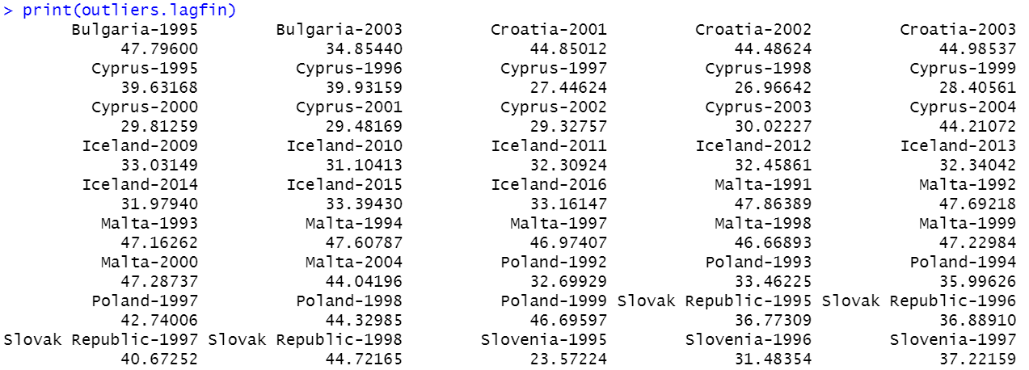

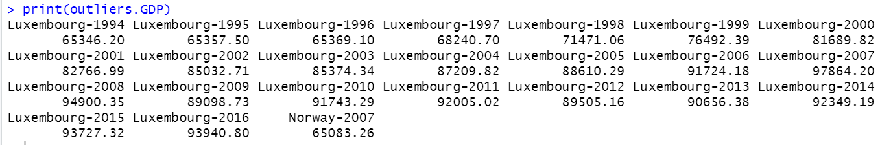

The distribution of our X1 and Y is shown in the histograms below (figure 2). X1 shows left skewedness while Y shows right skewedness (Section #H in R script).

Figure 2. Histogram of X1 and Y1 with Probability densities.

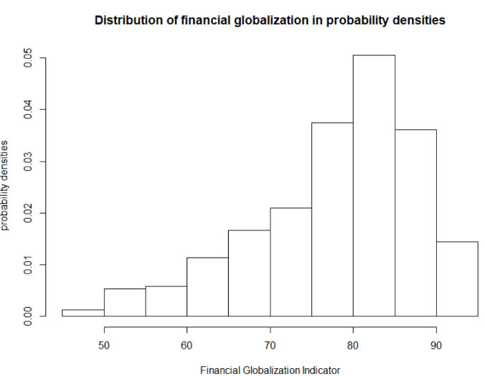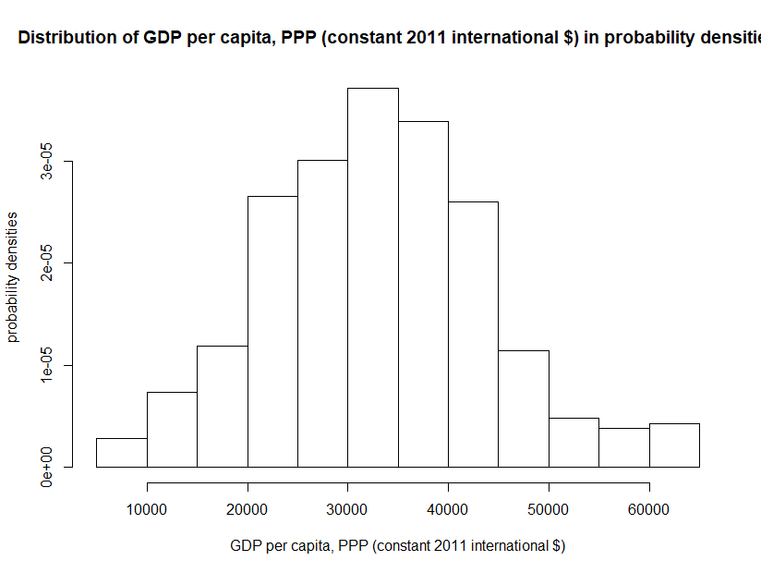

**3.3 Panel Data Analysis (Section #3 in R Script)**

For statistical analysis of our data, panel data (longitudinal data or temporal dimension to cross-sectional data) regression analysis is conducted using the plm package. Our panel data is unbalanced due to merging datasets as mentioned above. Panel data regression is performed using our IV, DV, and control discussed above and adding in fixed country and fixed time effects. Fixed country effects are used to account for unique characteristics of each countries to remove unobserved time-invariant heterogeneities across countries. The fixed country effects assign country specific intercepts of the regression line for each country. Also, fixed time effects are used to control for variables that are constant across countries but vary over time to eliminated omitted variable bias. The panel data regression result is shown in figure 3 below.

Figure 3 (Panel Data Regression Outliers Removed, Control for labor force participation rate)

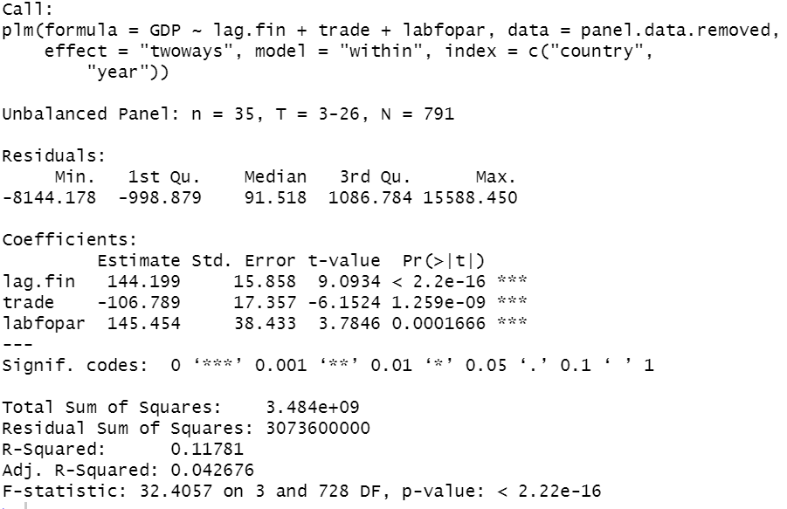

The results for the panel data regression with outliers removed, controlled for trade globalization and labor force participation rate, with fixed country and time effects, shows statistical significance as p value is below 0.05. Also, the coefficient for lag.fin (lagged financial globalization indicator or X1) indicates that holding everything else equal, for every 1 point increase in the lagged financial globalization (de jure) indicator(scaled from 0 to 100), GDP PPP Per Capita increases by $144.199.

**3.4 Partial Regression Plots (Section #4 in R script).**

In order to assess the relationship between our IV and DV, Bivariate plots do not suffice because there are multiple independent variables on top of our explanatory variable. Instead, we use the partial regression plot (added variable plots) to depict the relationship between GDP PPP Per Capita and lagged financial globalization (de jure), adjusting for the effects of other x variables including trade globalization (de jure), labor force participation rate, country, and year. This equation plots residuals of GDP PPP Per Capita after a regression on X2 = trade globalization (de jure), X3 = labor force participation rate, X4 = country, X5 = year against the residuals of lag.fin after regressing it on X2 = trade globalization (de jure), X3 = labor force participation rate, X4 = country X5 = year. This partial regression plot is seen below (figure 4).

Figure 4. Partial Regression Plots with Outliers and without Outliers

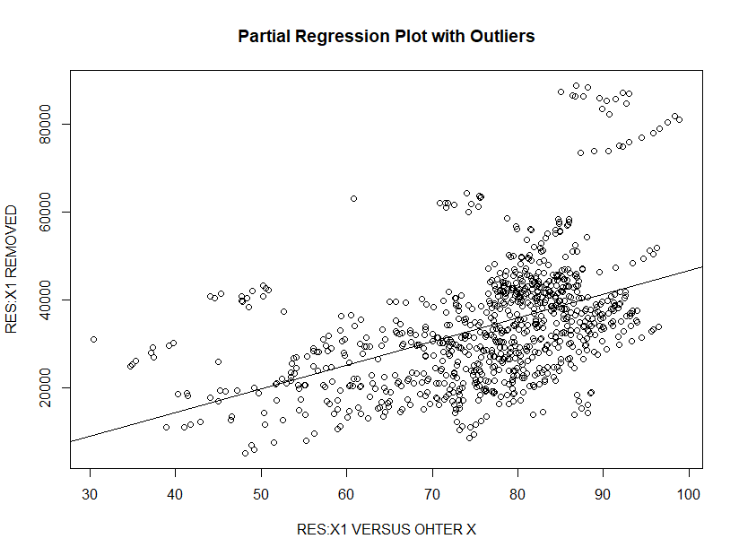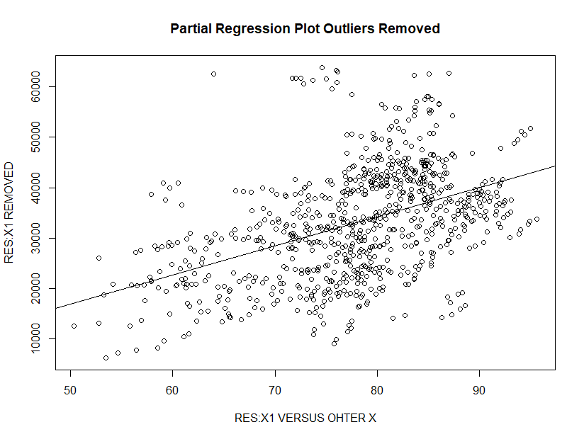

The partial regression plot allows us to see the leverage points and influential points. Leverage points are observations with an extreme value on a predictor variable and a measure of how far an independent variable deviates from its mean. These leverage points can change the regression coefficients if removed. Also, high leverage points are horizontally distant from rest of the data because when we regress X1 = X2 + X3 + X4 + X5 and store the residuals, the large residuals come from an observation of X1 which has a unusual value given its values for X2 + X3  + X4 + X5. If the high-leverage observation also is unusual in the *Y* direction, it is said to be

Influential. Influential points are outliers that greatly affects the slope of the regression line. Removing influential points substantially changes the estimate of coefficients.

Comparing both of the partial regression plots using boxplot outliers effectively removed the leverage and influential points. Refer to figure 1 above. As we can see in the arbitrarily drawn vertical red line (RES:X1 vs. other X <50) and the horizontal line (RES: X1 REMOVED >= $60,000) for both of the partial regression plots, using boxplot outliers effectively removed the leverage and influential points. The outlier treatment removed points that are left to the red vertical line (RES:X1 vs. other X <50), which were high leverage points that are horizontally distant from the rest of the data. The treatment also removed points that are above the blue line (RES: X1 REMOVED >= $60,000), which were high influential points that is unusual in the Y direction.

As we can see in the regressed version of the partial regression plot in figure 5 where outliers exist and figure 6 where outliers are removed, removing outliers using boxplot decreased the p value from 0.00759 (figure 5) to 0.00015 (figure 6), making the partial regression plot more statistically significant. Also, the coefficient for the slope of the regression line for the partial regression plot also increased from 539.74 GDP PPP Per Capita to 577.94 GDP PPP Per Capita.

Figure 5. Regressed Version of the Partial Regression Plot

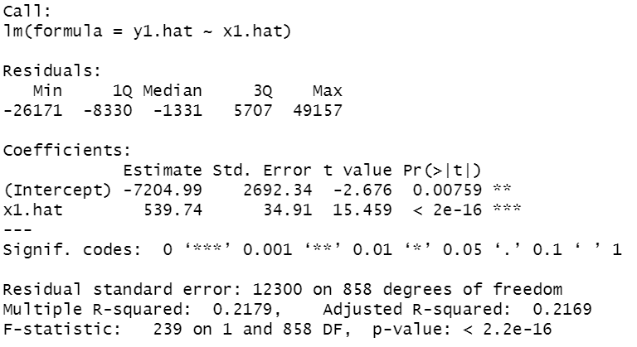

Figure 6. Regressed Version of the Partial Regression Plot (Outliers Removed)

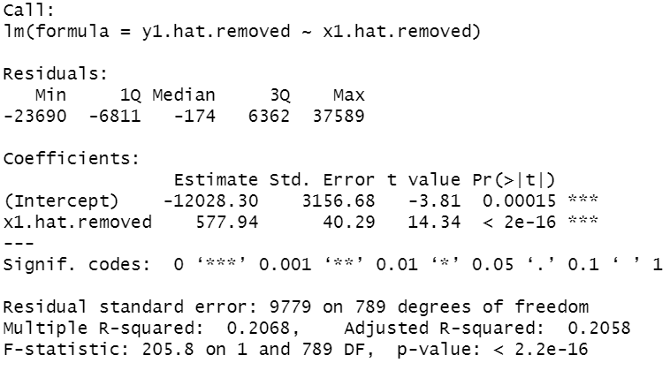

**4. Limitations & Conclusion**

Although our panel data regression shows that holding everything else equal, for every 1 point increase in the lagged financial globalization (de jure) indicator (scaled from 0 to 100), GDP PPP Per Capita increases by $144.199, we do not have sufficient evidence to claim that there is a positive association between the financial globalization indicator (de jure) and GDP PPP Per Capita. Indeed the panel data regression was checked using the partial regression plot with control variables and adjusting for country and time fixed effects. Concomitantly, outliers were removed effectively that statistical significance increased and p-value decreased even for the partial regression plot. However, there are still many steps that needs to be taken in order to claim confidently that our X1 is positively correlated with Y.

First, there are a myriad of limitations. First, is that not all confounding variables were ruled out. For example, a possible confounder may be that Democracies are more likely to have higher financial globalization indicators (de jure) while at the same time have high GDP PPP Per Capita. Also, Gross Domestic Product intends to capture a nation’s economy holistically. As a result, many of the potential confounders in the dataset that would have been included in the control variable cannot be included because the confounders were mechanically related with GDP. For example, in the KOF dataset, there is “informational globalization” where it measures high technology exports (appendix A). We might think that this indicator should be our control variable because it is likely that countries with high technology exports have high GDP PPP Per Capita. However, we cannot include this indicator because ‘exports’ are mechanically correlated with GDP.

Furthermore, even if we were to control for are the confounders in our statistical analysis, the results would still be obscure because the “financial globalization indicator (de jure)” is dubbed as an indicator but in reality, is an index variable. This indicator measures 4 different variables from each different datasets and aggregates each different variables to an index variable. In turn, we cannot clearly define which variables inside the indicator is actually leading to an increase in GDP PPP Per Capita even if we were able to rule out all different confounders. Unfortunately, the KOF Index Dataset does not provide a breakdown of the variables for the indicators. Ideally, if we could measure the counterfactual, we would be able to claim causality between our X1 and Y. For example, for countries that had an increase in both financial globalization (preferably a more specific measure than financial globalization) and GDP PPP Per Capita(preferably a more specific measure than GDP PPP Per Capita), we would want to observe what would happen to GDP PPP Per Capita if financial globalization did not increase. Lastly, as aforementioned, missing values limited time periods to be only from 1991 to 2016. Ideally, we would want every data points from 1960 to 2018 for every country for all our Xn and Yn variables.

In conclusion, there are various limitations as noted above that must be addressed before judging any association or causality between the financial globalization indicator (de jure) and GDP PPP Per Capita. Although some of the limitations denoted above are not possible such as measuring the counterfactual by going back in time, further suggestions for research can be made. First, democracies and other confounders should be included as the control variable if we wanted to continue analyzing the relationship between the financial globalization indicator and GDP PPP Per Capita. Lastly, there are more complexed statistical analysis available. In lieu of removing outliers by using standard deviation, the “Hat Matrix” can quantify the leverage of an observation. Additionally, using ARIMA models to model serial correlation and conducting the Hausman test to determine whether to use random or fixed effects can be beneficial.